**Operating System and Design (19CS2106A)**

**Advanced Lab- 6**

**Xv6 design, implementation, and customization.**

1. **System call tracing**

System call tracing (moderate) ... You have to modify the xv6 kernel to print out a line when each system call is about to return, if the system call's number is set in the mask. The line should contain the process id, the name of the system call and the return value; you don't need to print the system call arguments.

You can use strace command to trace the execution of any executable.

The following example shows the output of strace for the Linux ls command.

Strace monitors the system calls and signals of a specific program. It is helpful when you do not have the source code and would like to debug the execution of a program. strace provides you the execution sequence of a binary from start to end.

BELOW COMMANDS ARE executed in putty :-------------------

strace ls,

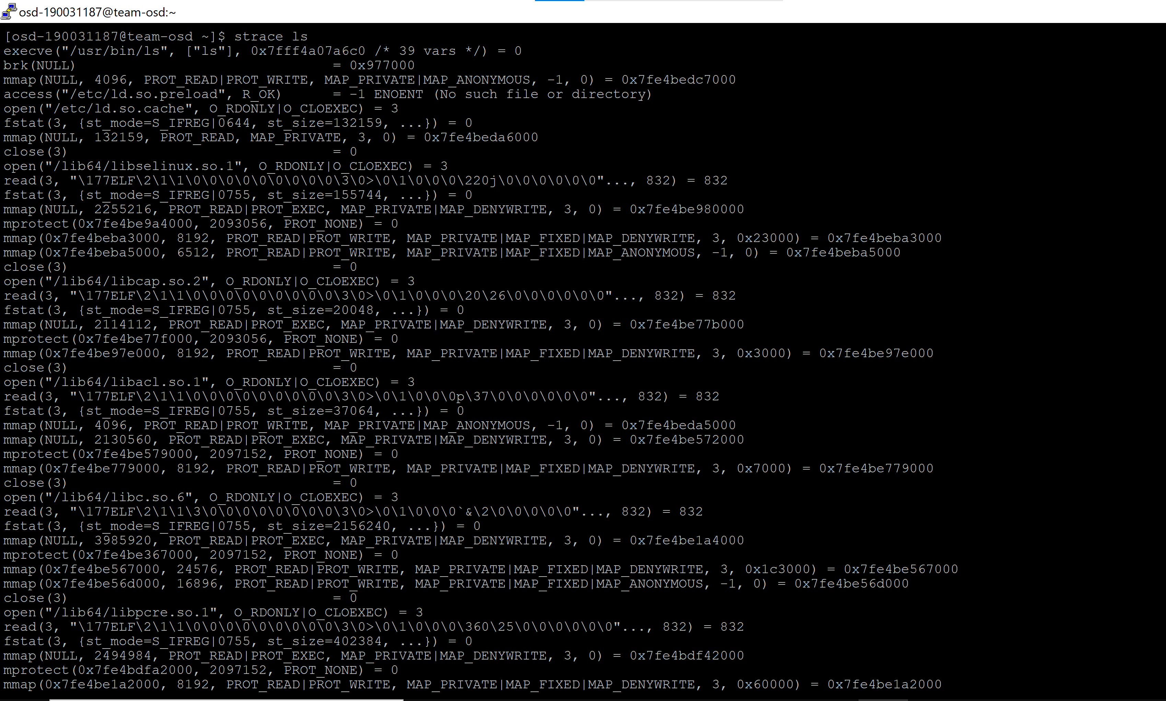

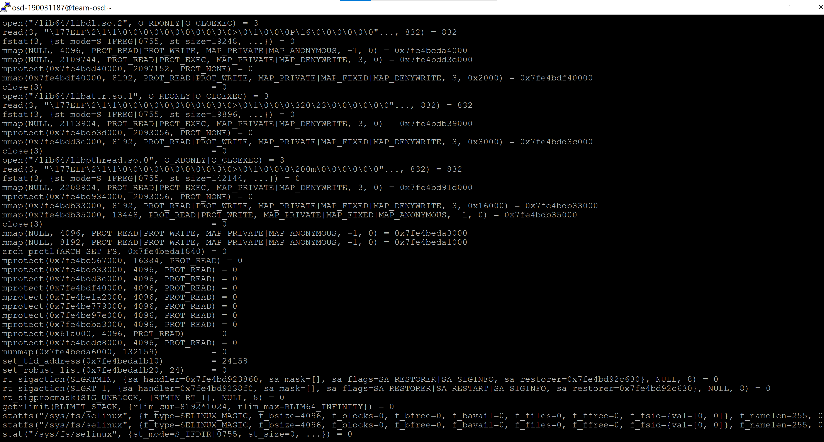

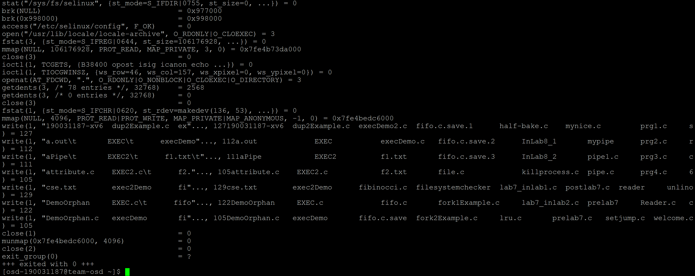

strace -e open ls,

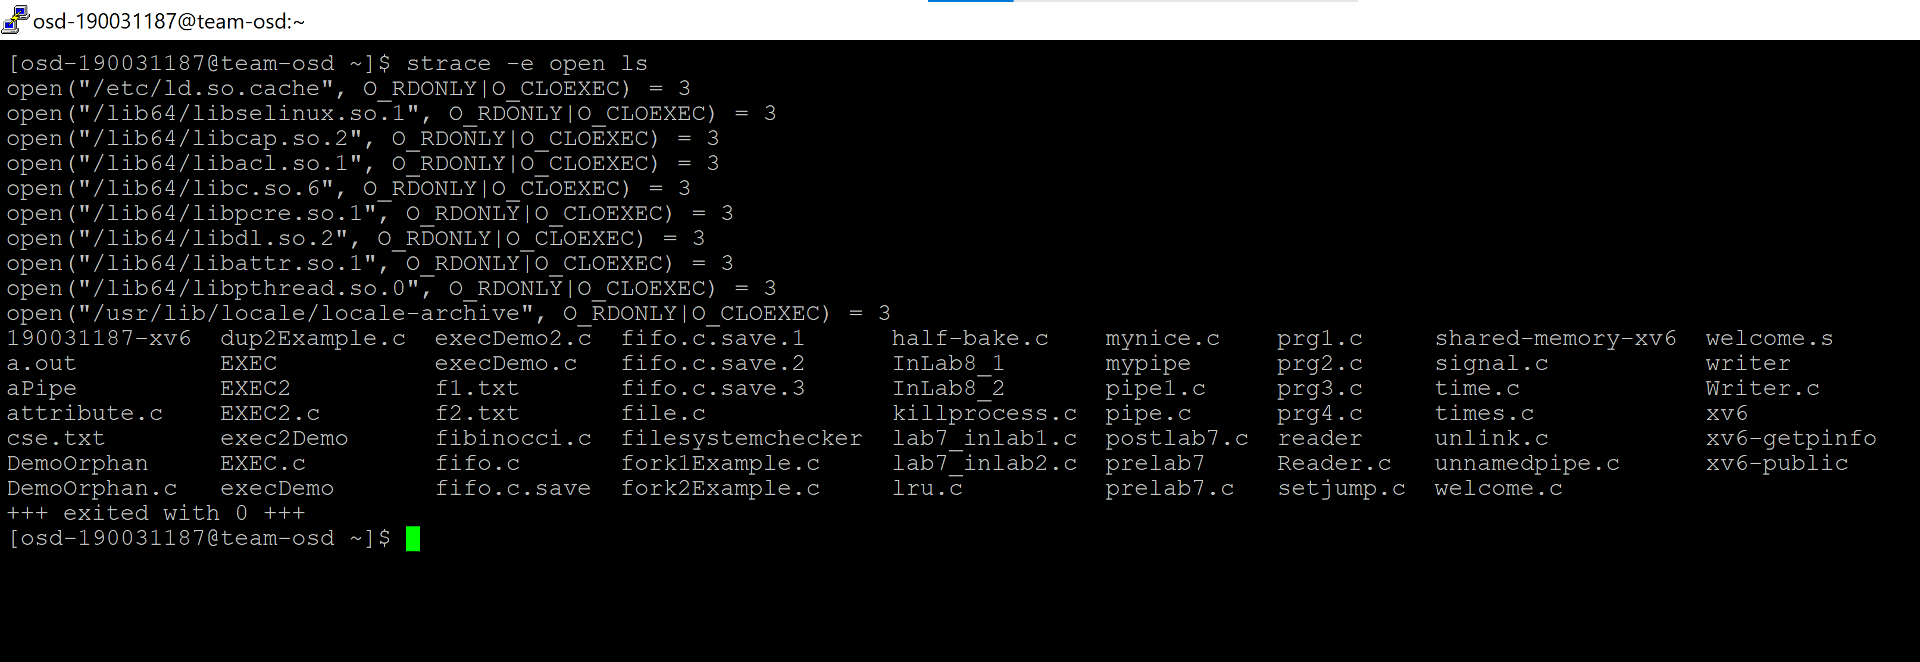

strace -e trace=open,read ls /home

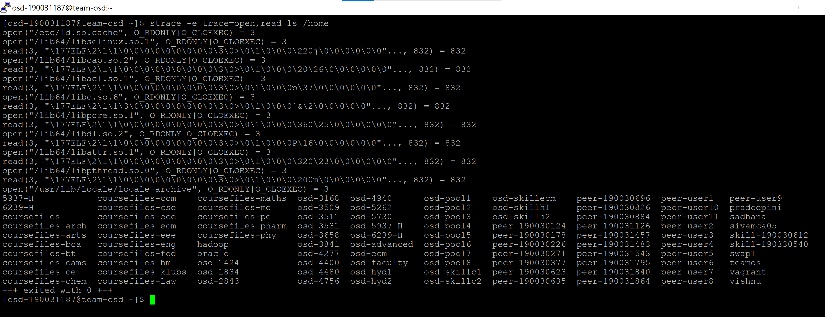

strace -o output.txt ls,

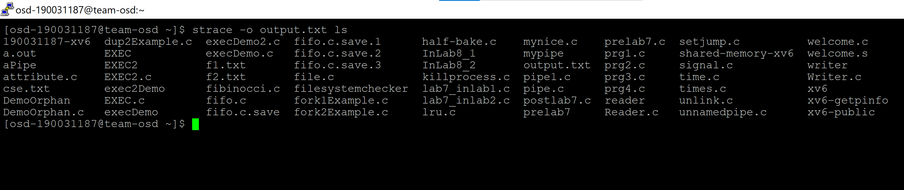

cat output.txt

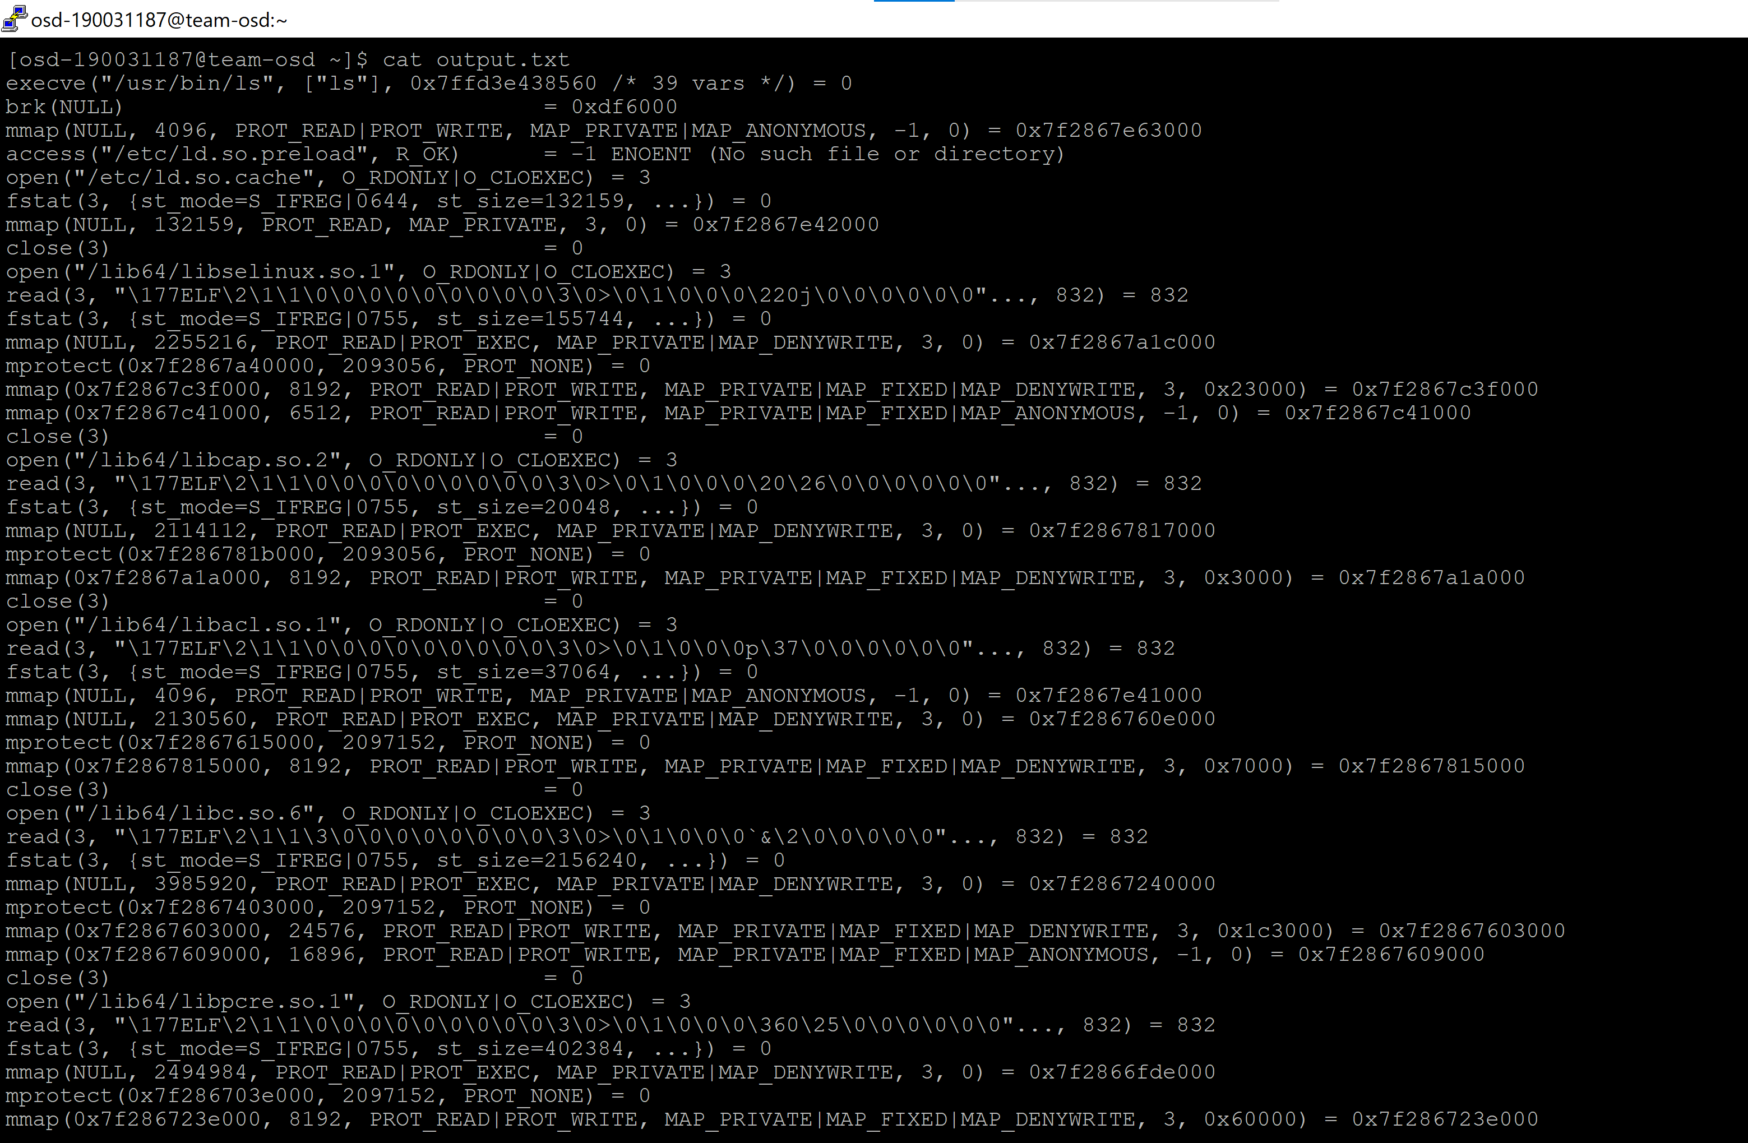

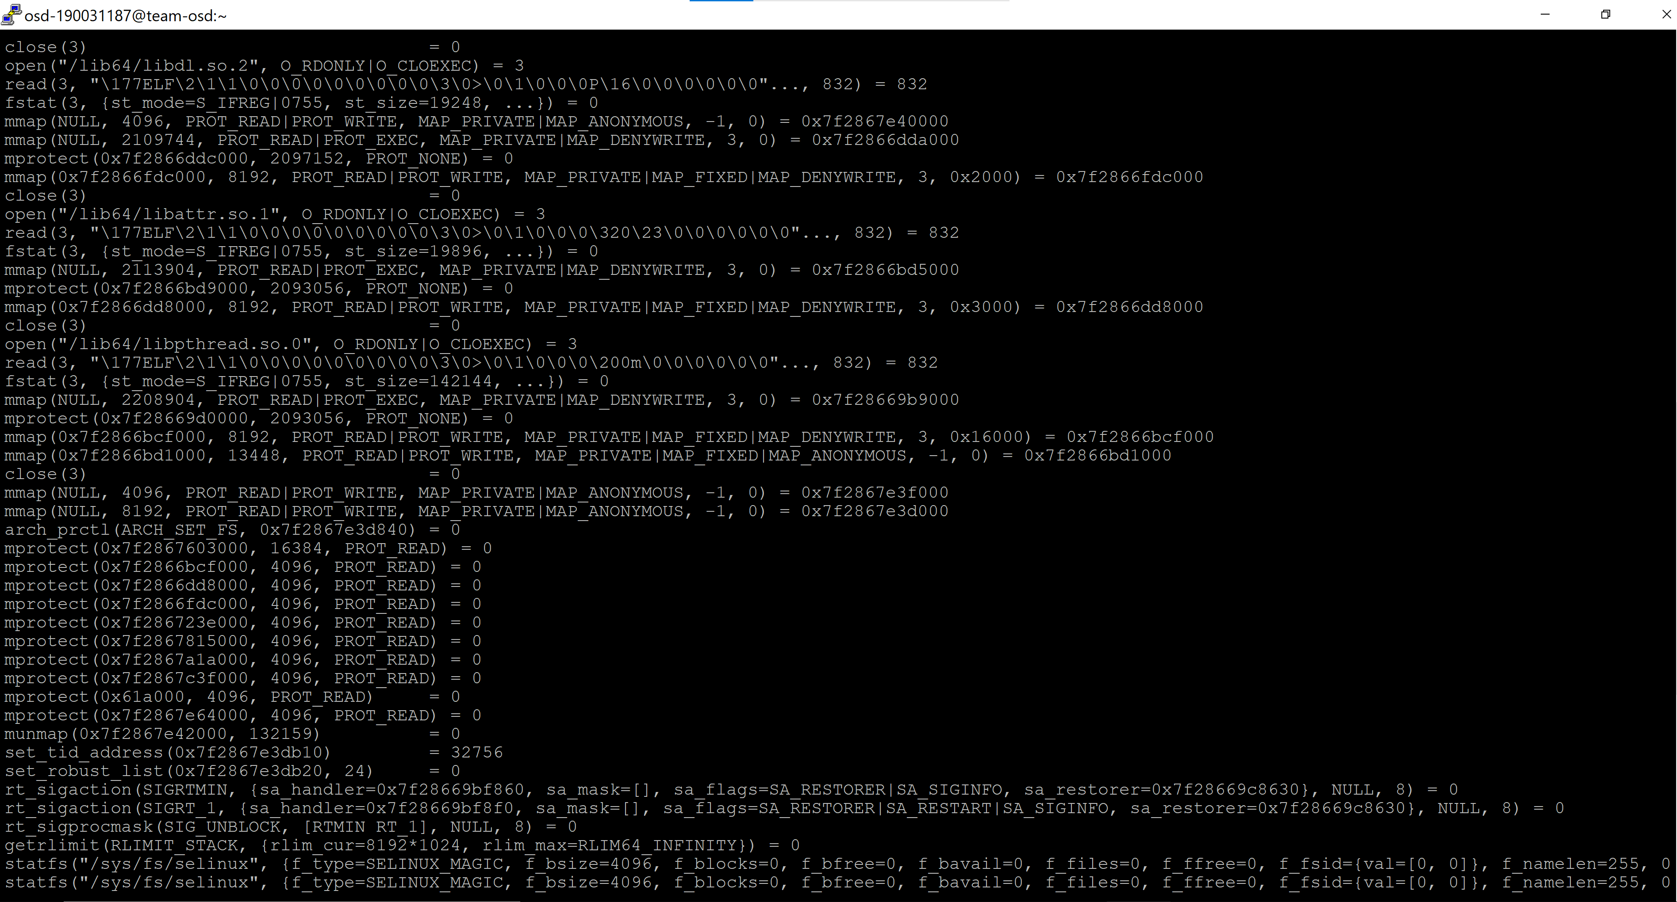

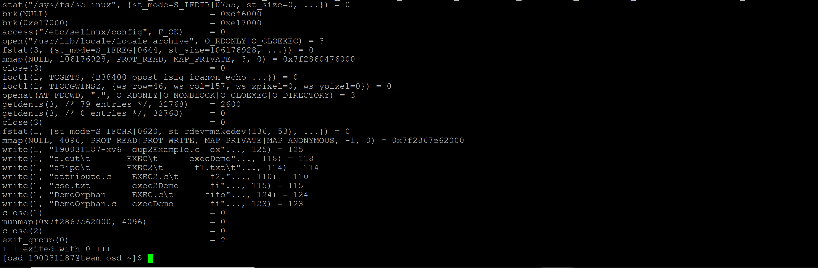

strace -p 1725 -o output.txt,

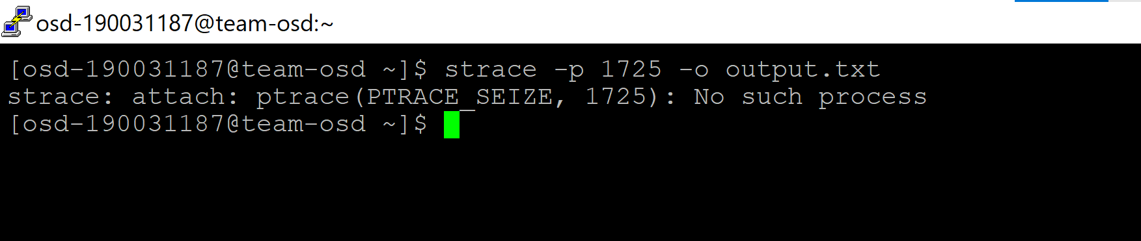

strace -t -e open ls /home,

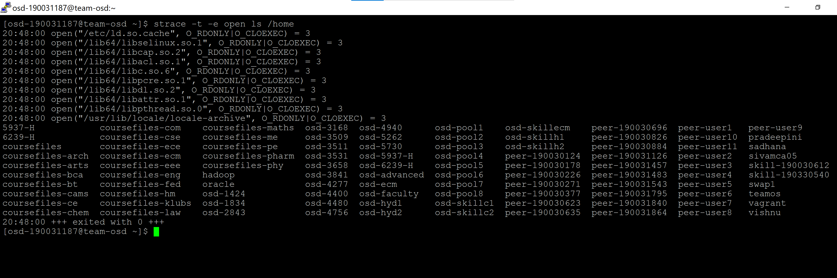

strace -r ls,

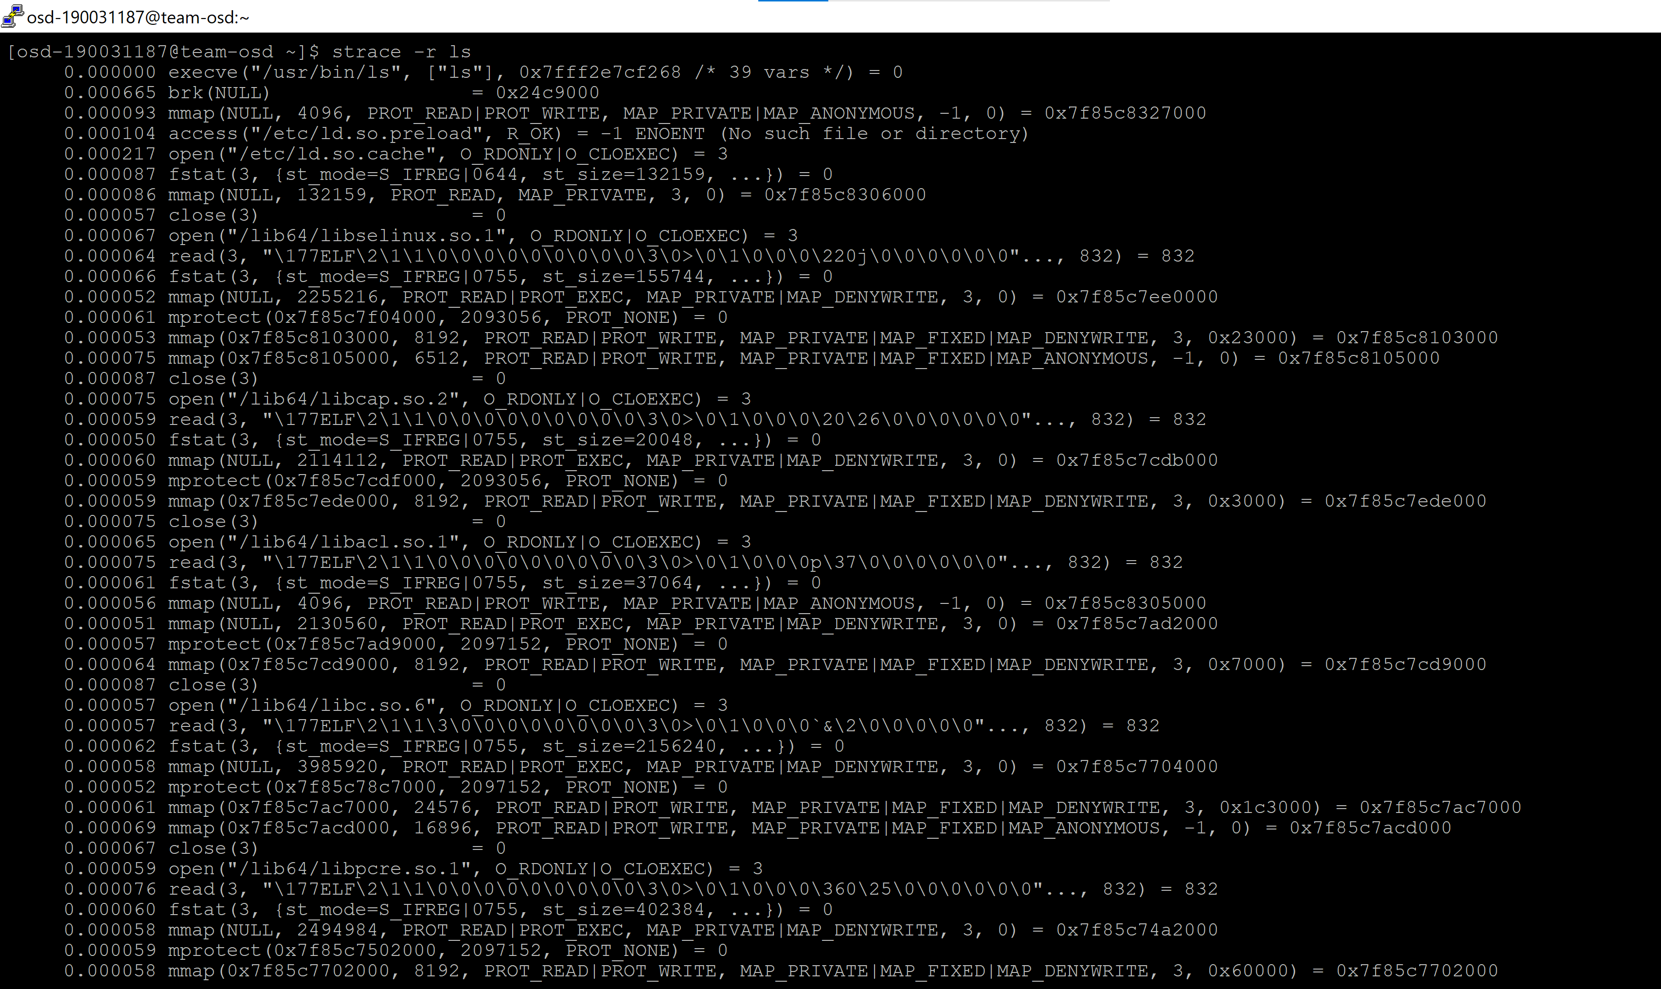

strace -c ls /home

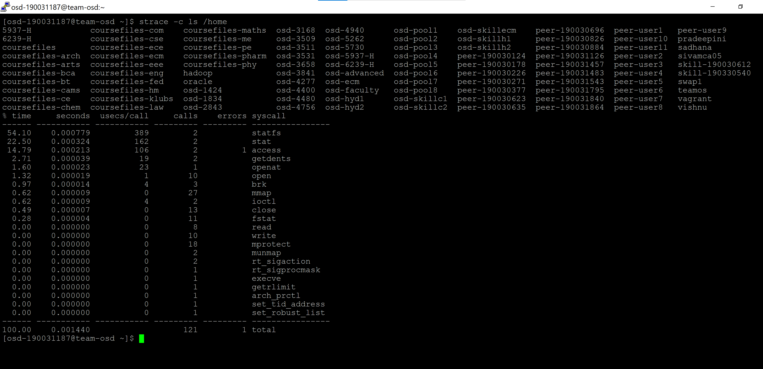

1. **Add support for symbolic links**

Symbolic links are basically advanced shortcuts. Create a symbolic link to an individual file or folder, and that link will appear to be the same as the file or folder to Windows—even though it’s just a link pointing at the file or folder. A symbolic link is simply a file with a special type (e.g., T_SYMLINK instead of T_FILE or T_DIR) whose contents contain the path being linked to. Turn in a short writeup of how you would change xv6 to support symlinks. Symbolic links were already present by 1978 in minicomputer operating systems from DEC and Data General's RDOS. Today they are supported by the POSIX operating system standard, most Unix-like operating systems such as FreeBSD, Linux, and macOS.

EXAMPLE PROGRAM FOR SYMBOLICLINK AND ITS EXECUTION

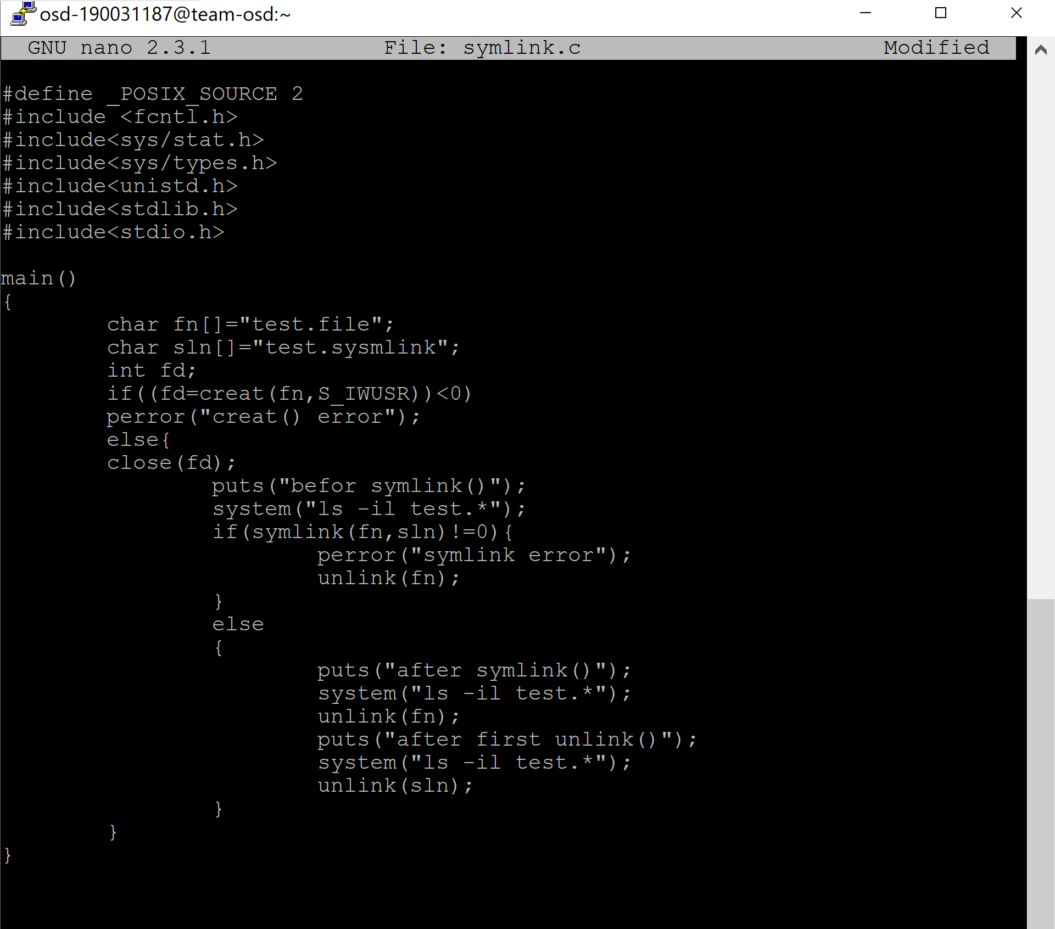

**OUTPUT**

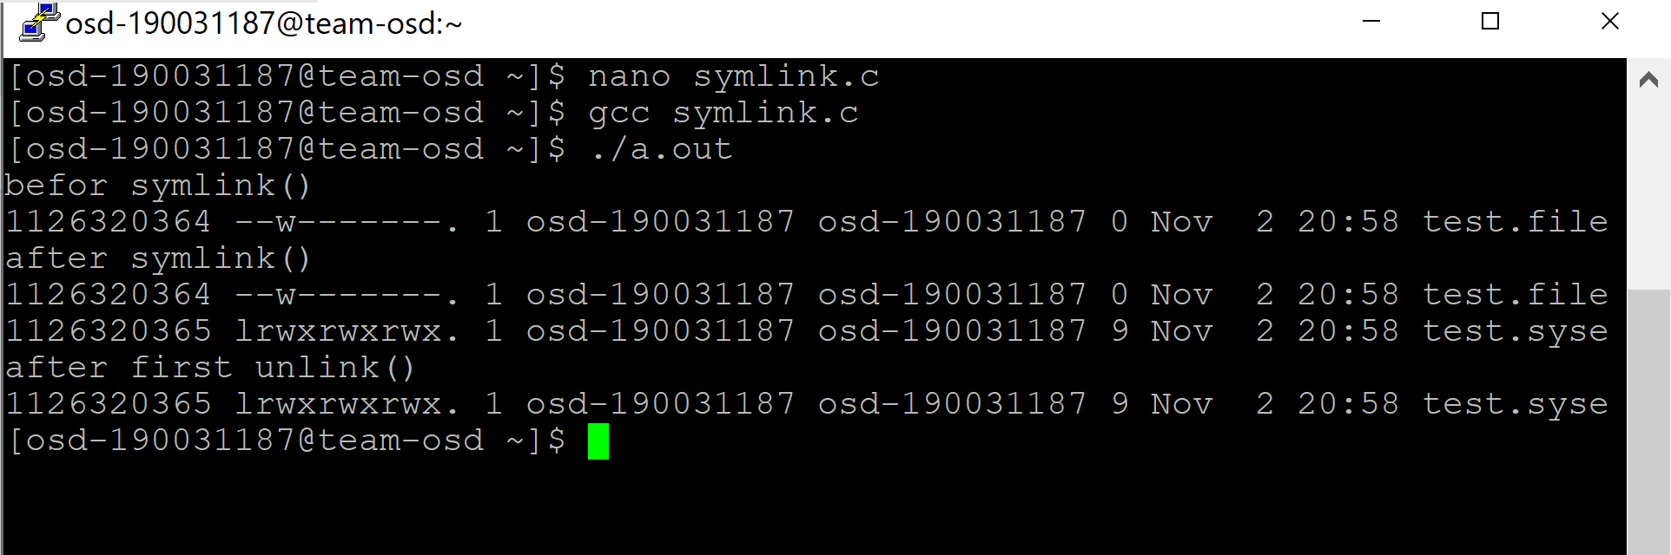

**UNIX system programming**

1. program using timer

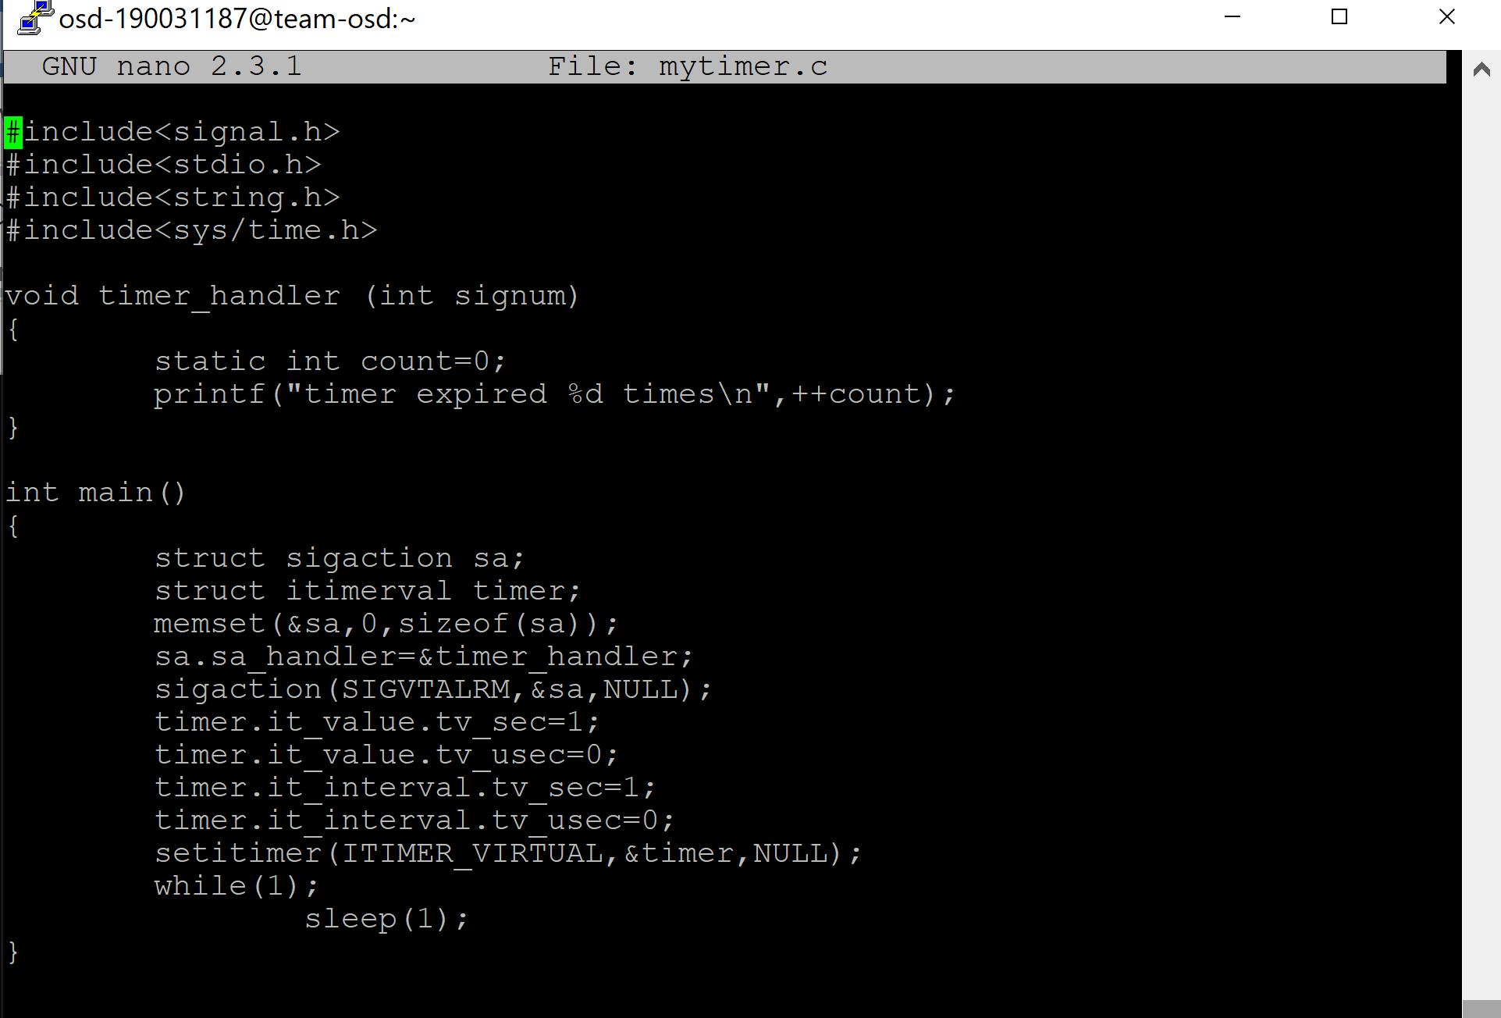

**OUTPUT**

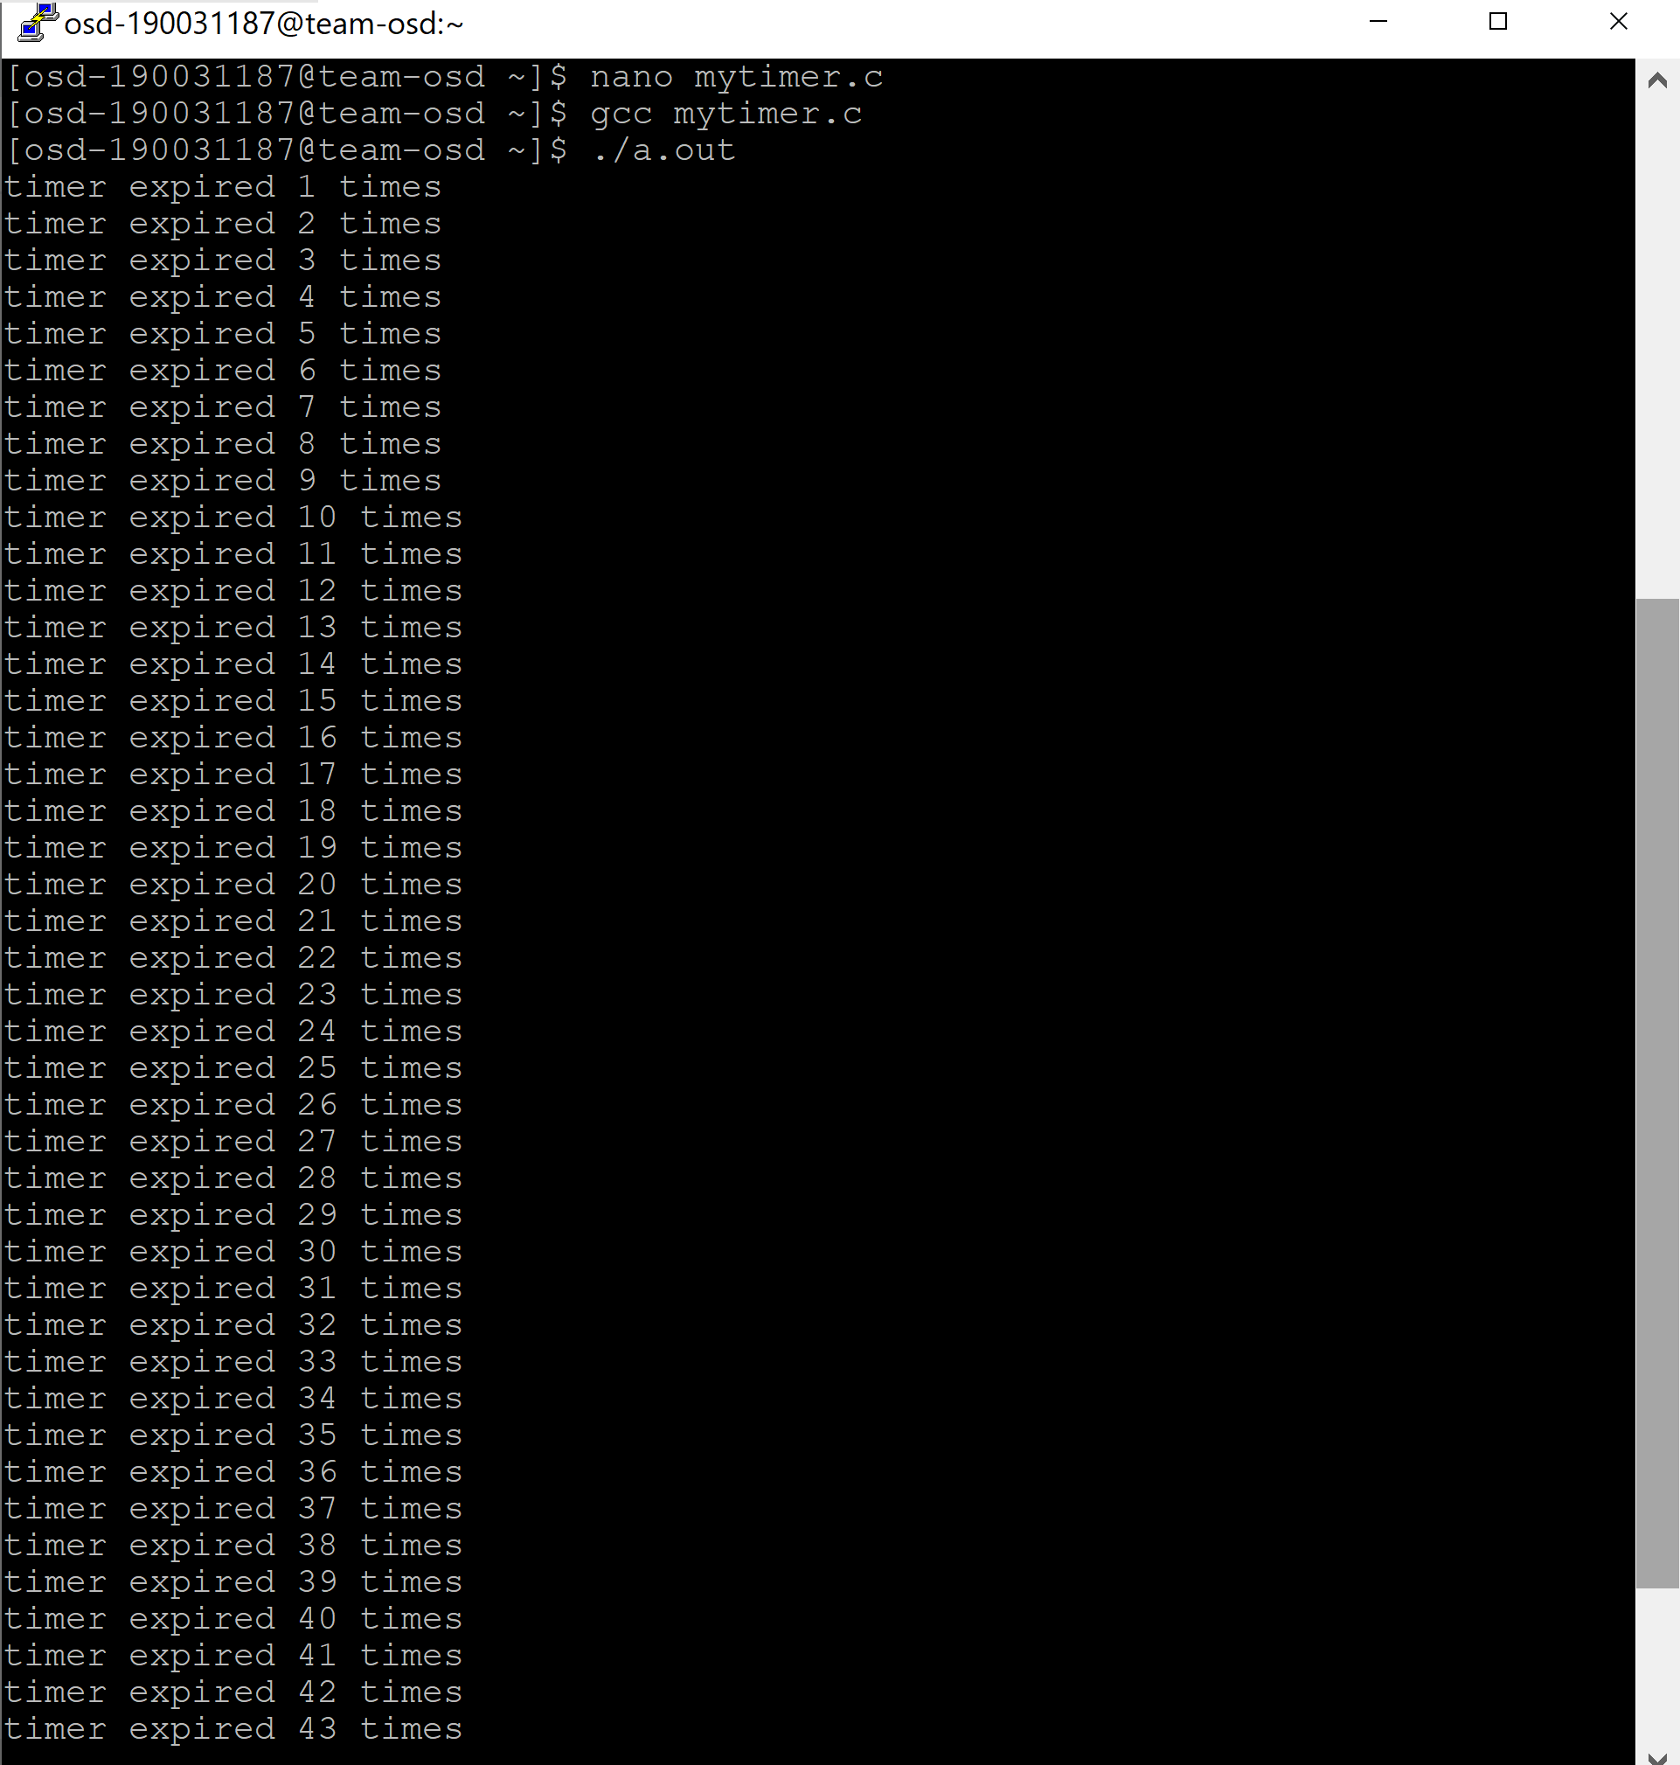

2. program using alarm call

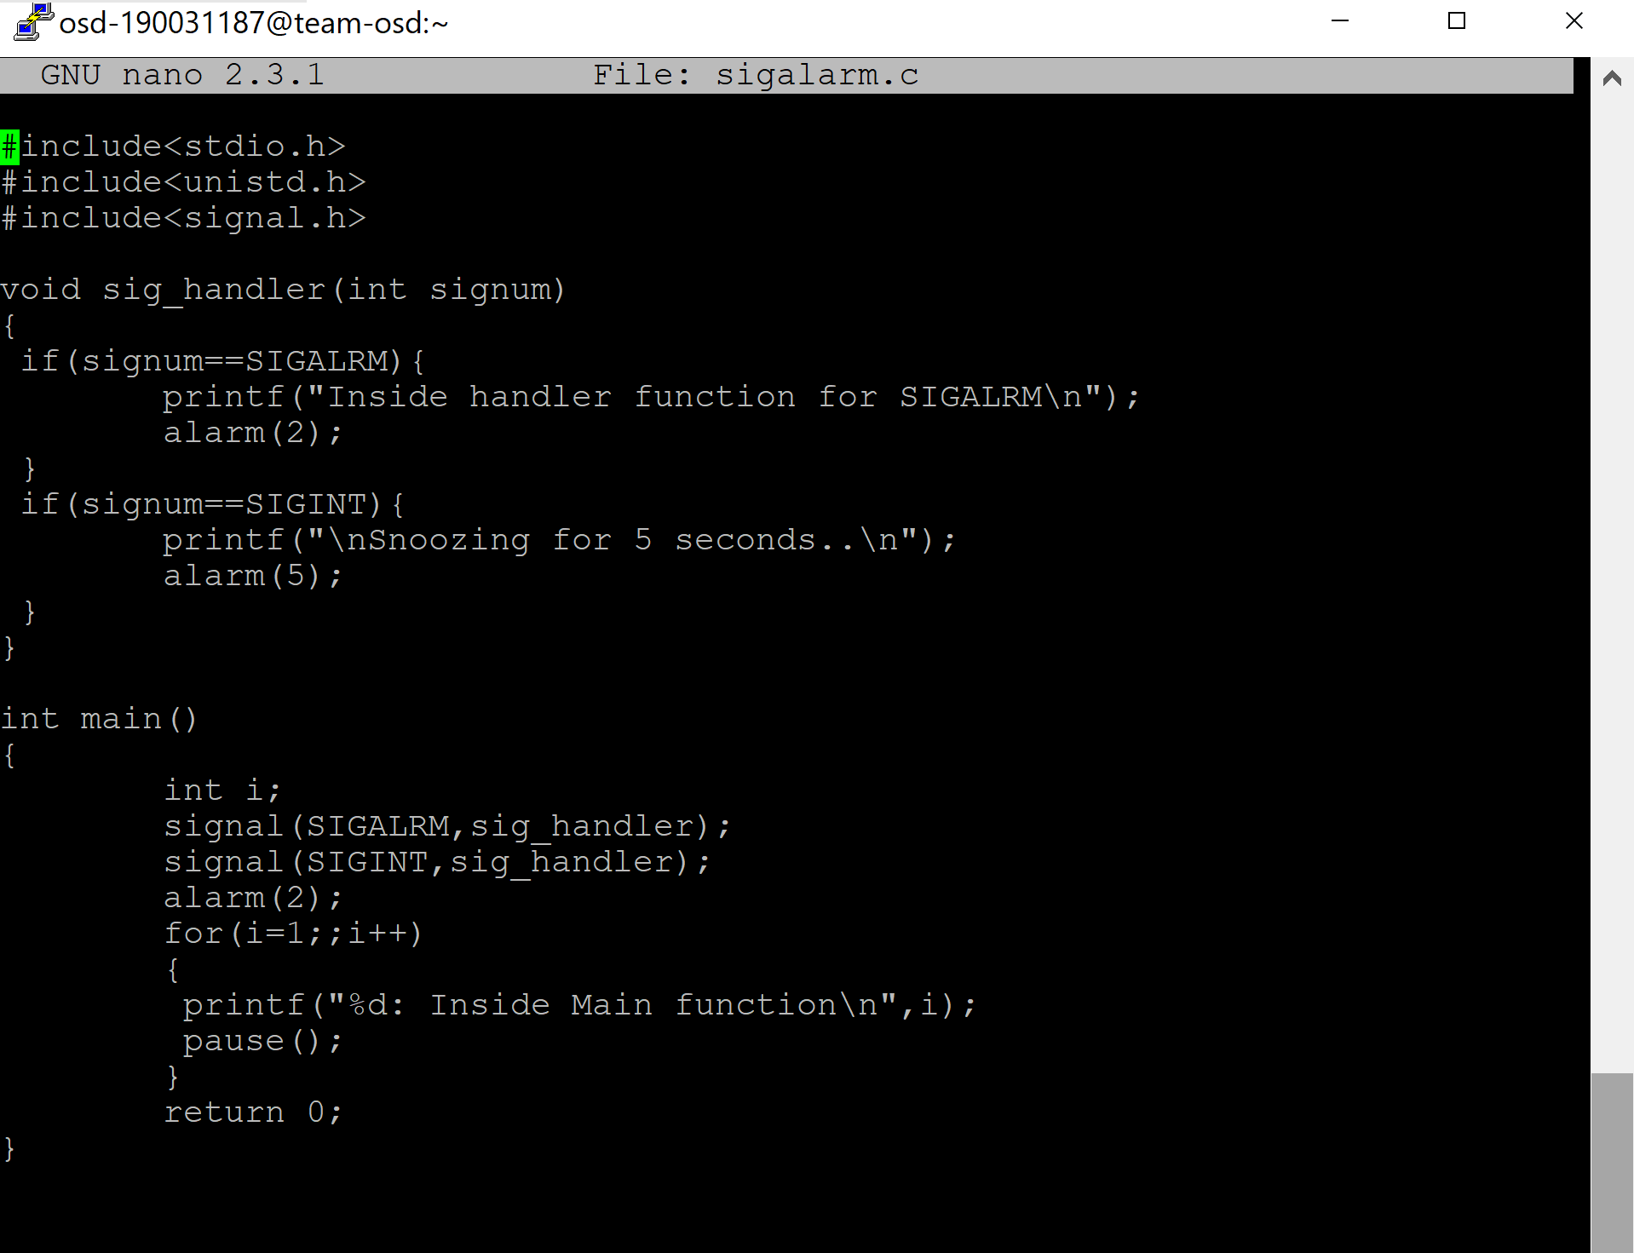

**OUTPUT**

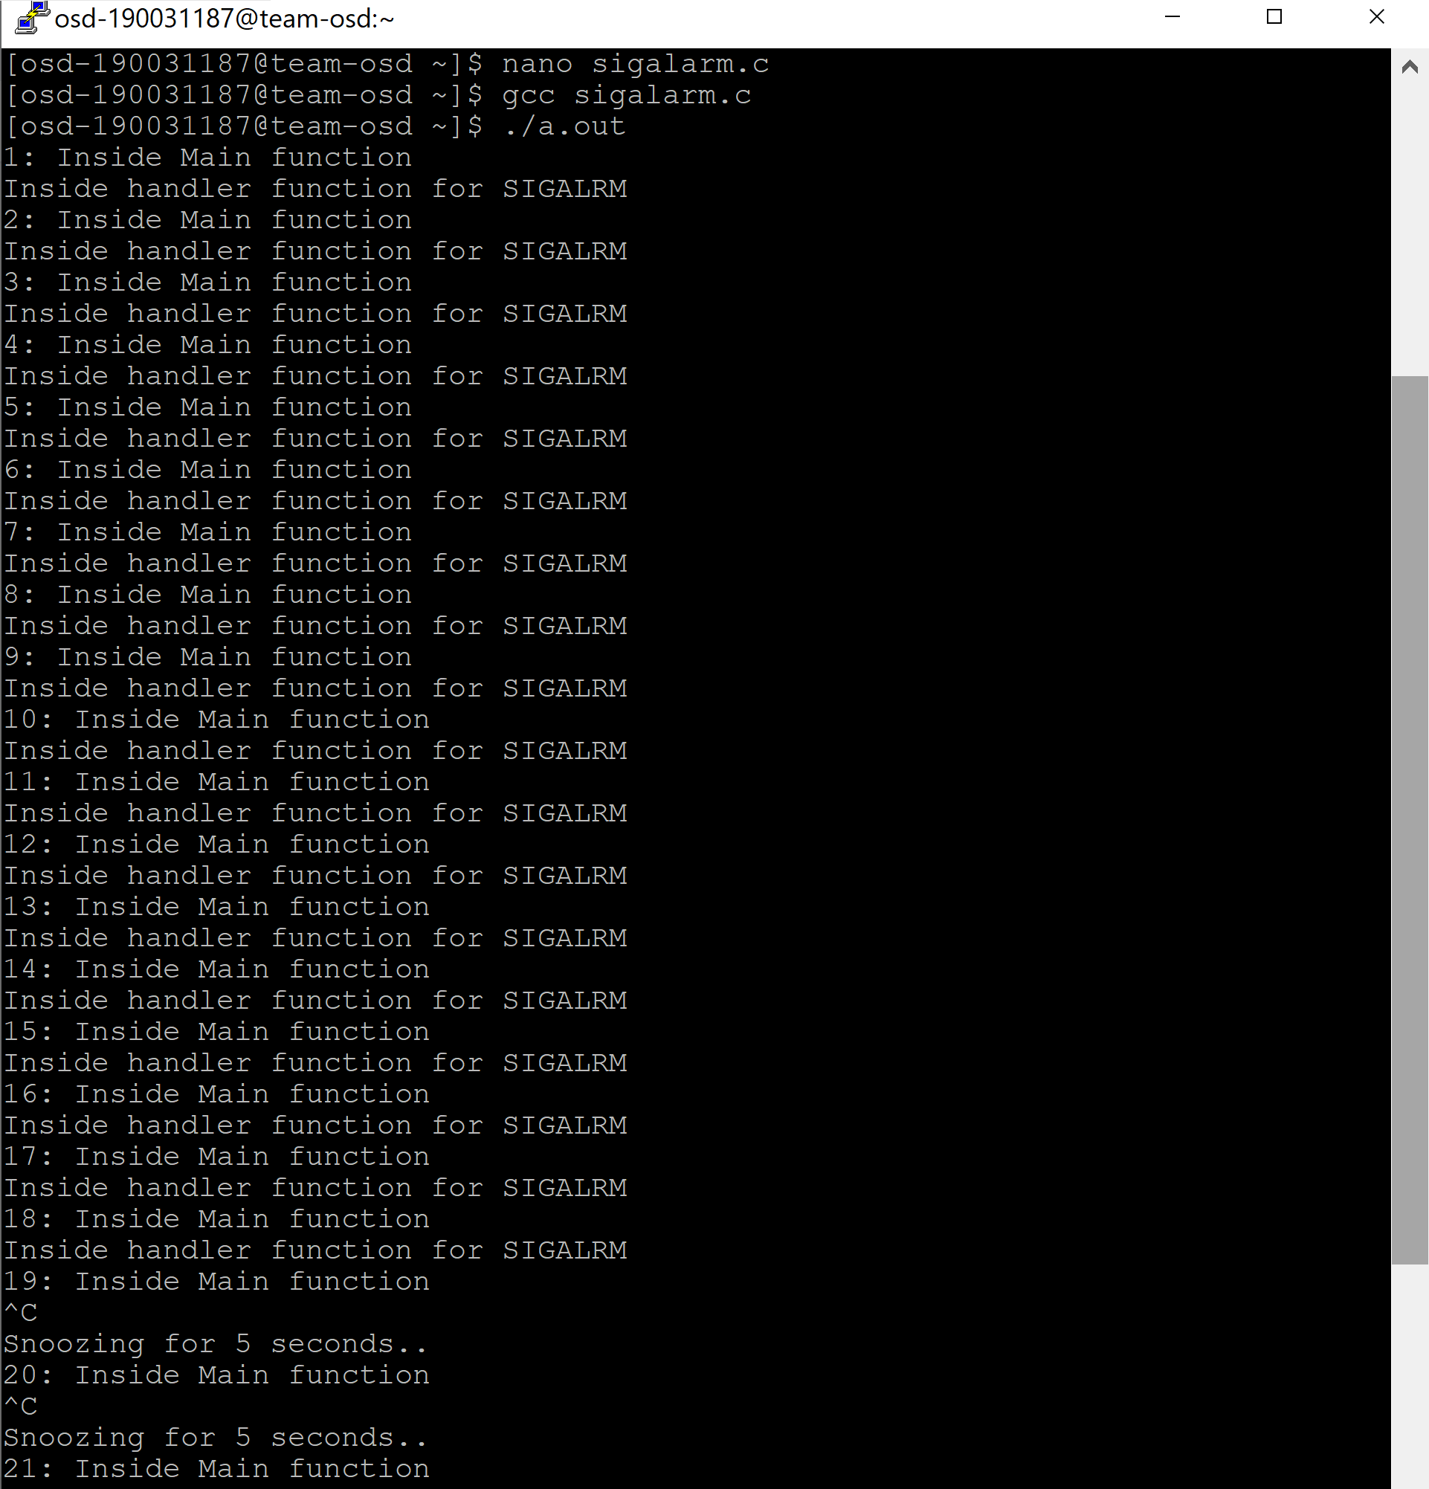

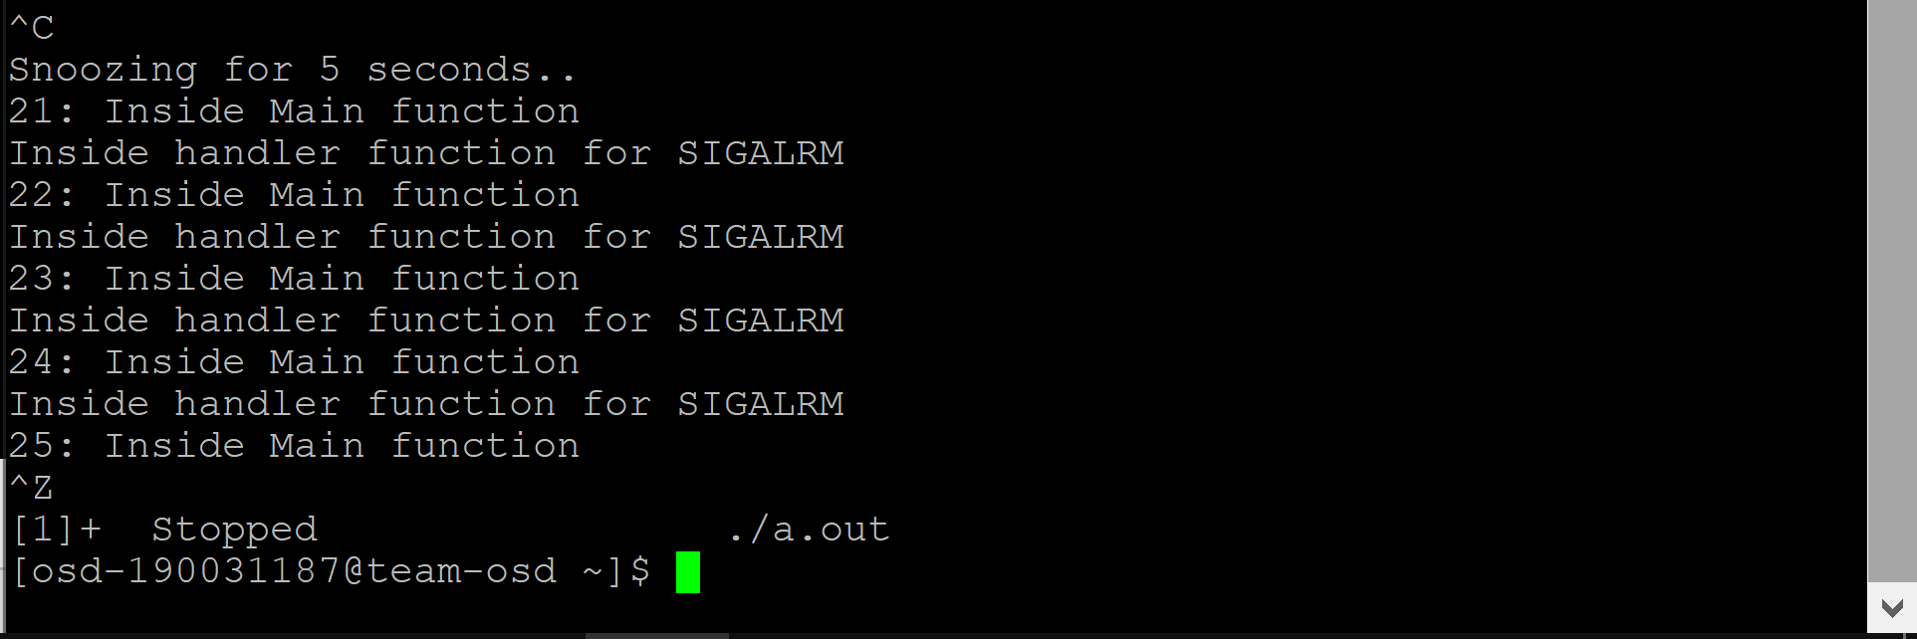

1. **program invoking profil system call**

The profil() function provides CPU-use statistics by profiling the amount of CPU time expended by a program. The profil() function generates the statistics by creating an execution histogram for a current process.

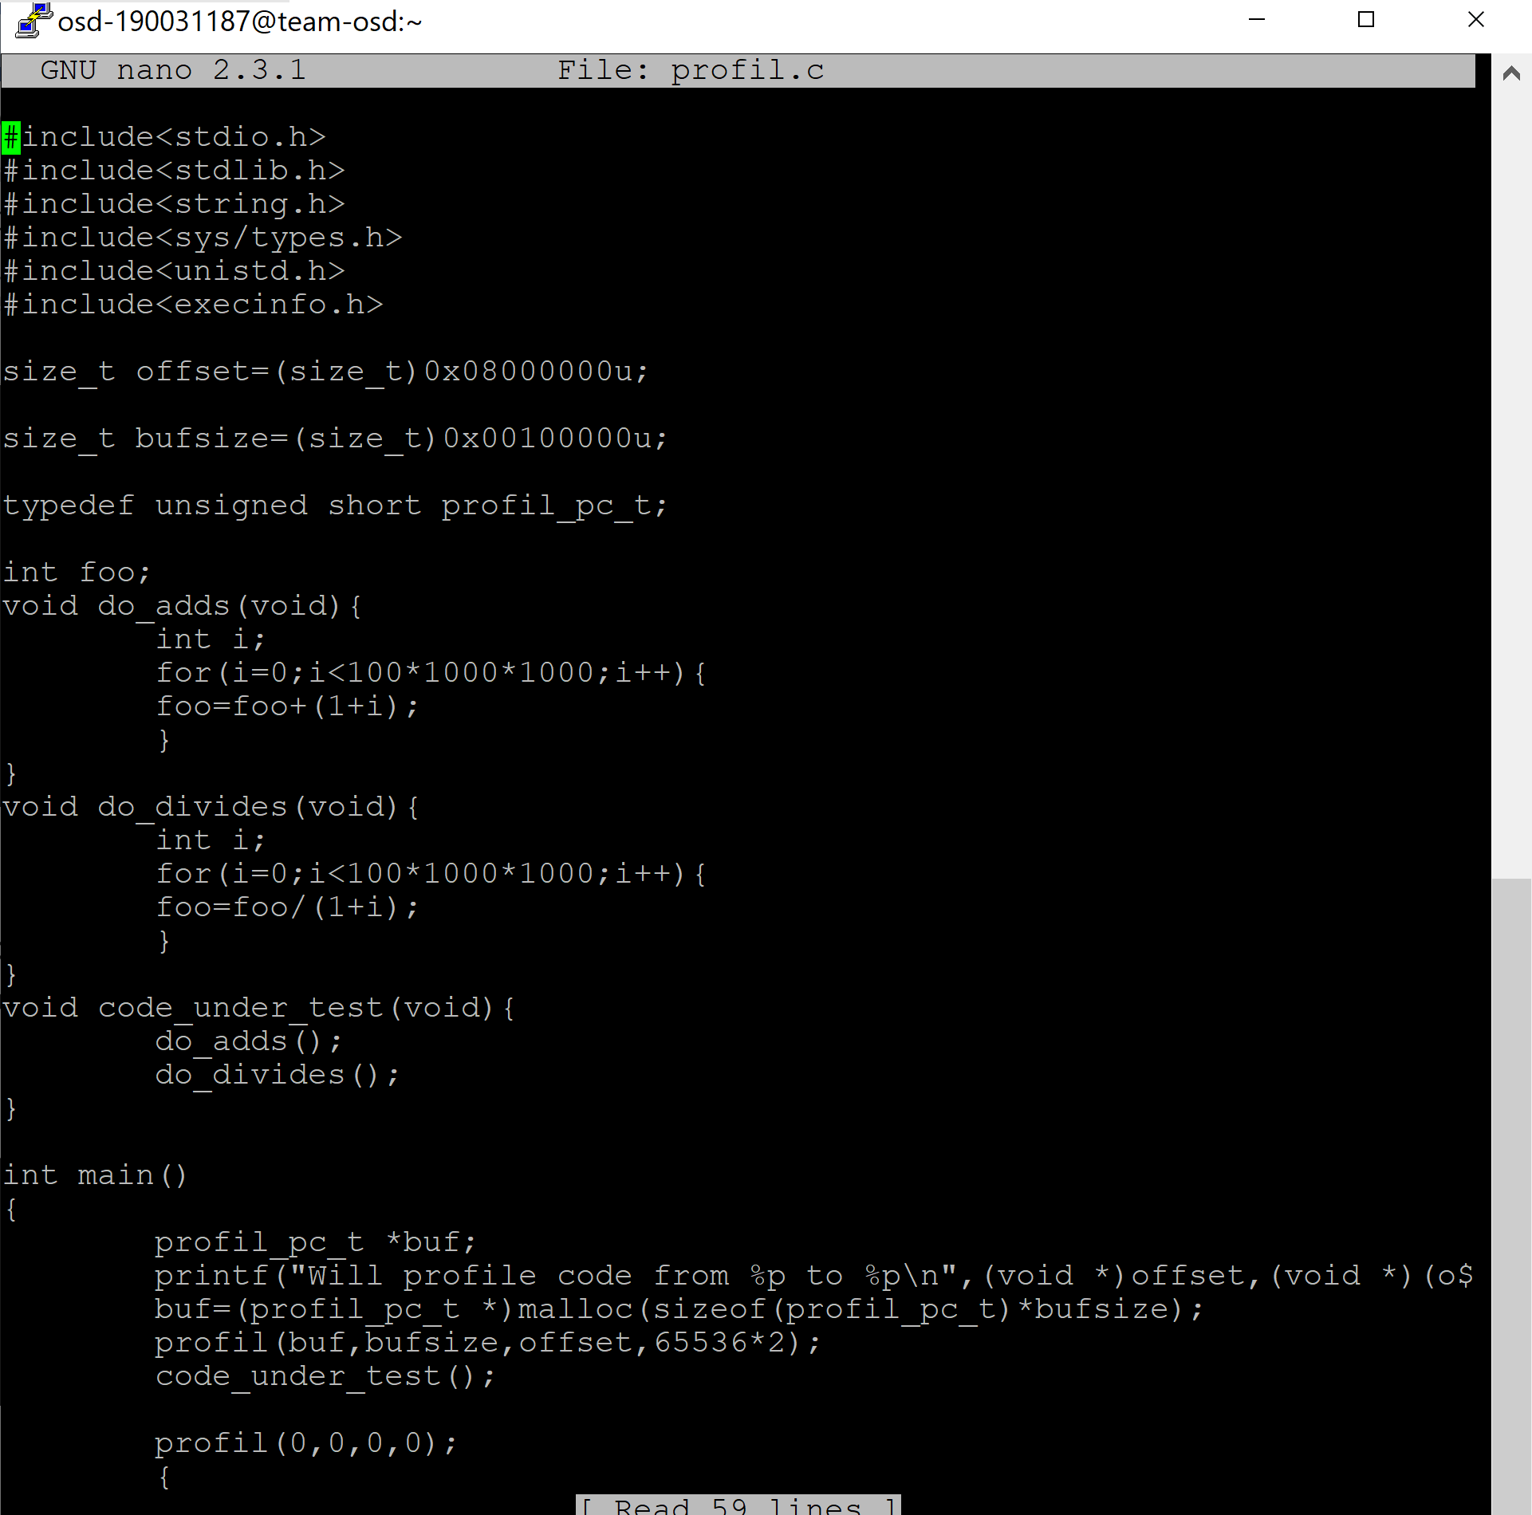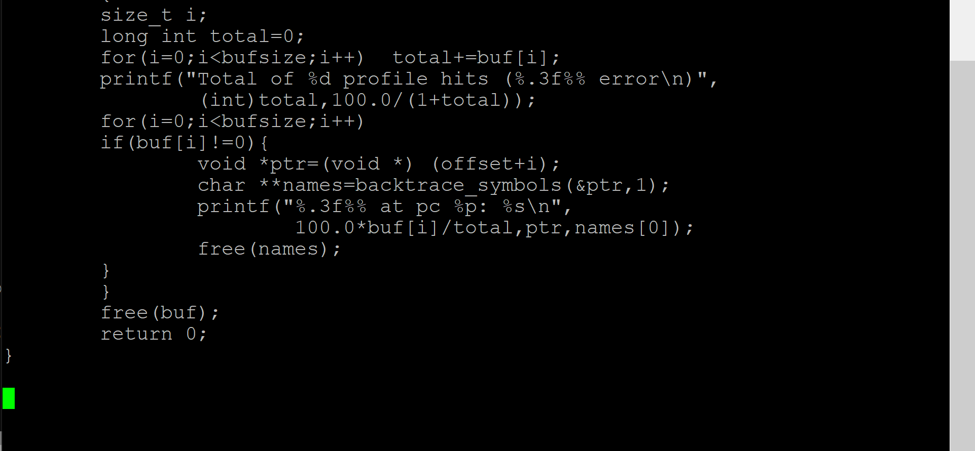

**OUTPUT**

